**SEMESTER TRAINING REPORT**

ON

**“THE RESTO”**

**FOOD DELIVERY WEBSITE**

Submitted in partial fulfillment of requirements for the award of the degree

***Bachelor of Technology***

***In***

***Computer Science and Engineering***

To

**I K Gujral Punjab Technical University, Jalandhar**

Submitted By

**PREEKSHIT DAHIYA**

**2019214**

**8th Semester**

**(2020-2024)**

Under the guidance

**Mr. Jagbir Singh Gill**

**Assistant Professor**



**Department Of Computer Science and Engineering**

**CGC College of Engineering**

**Landran -Mohali, 140307**

**May 2024**

**CERTIFICATE**

This is to certify that **Mr. PREEKSHIT DAHIYA** has partially completed / completed the Semester training during the period from **15th Jan 2024 to 16th Jun 2024** in our Organization / Industry as a partial fulfillment of Degree of **Bachelor of Technology in Computer Science & Engineering.**

**(Signature of Project Supervisor)**

**Date:**

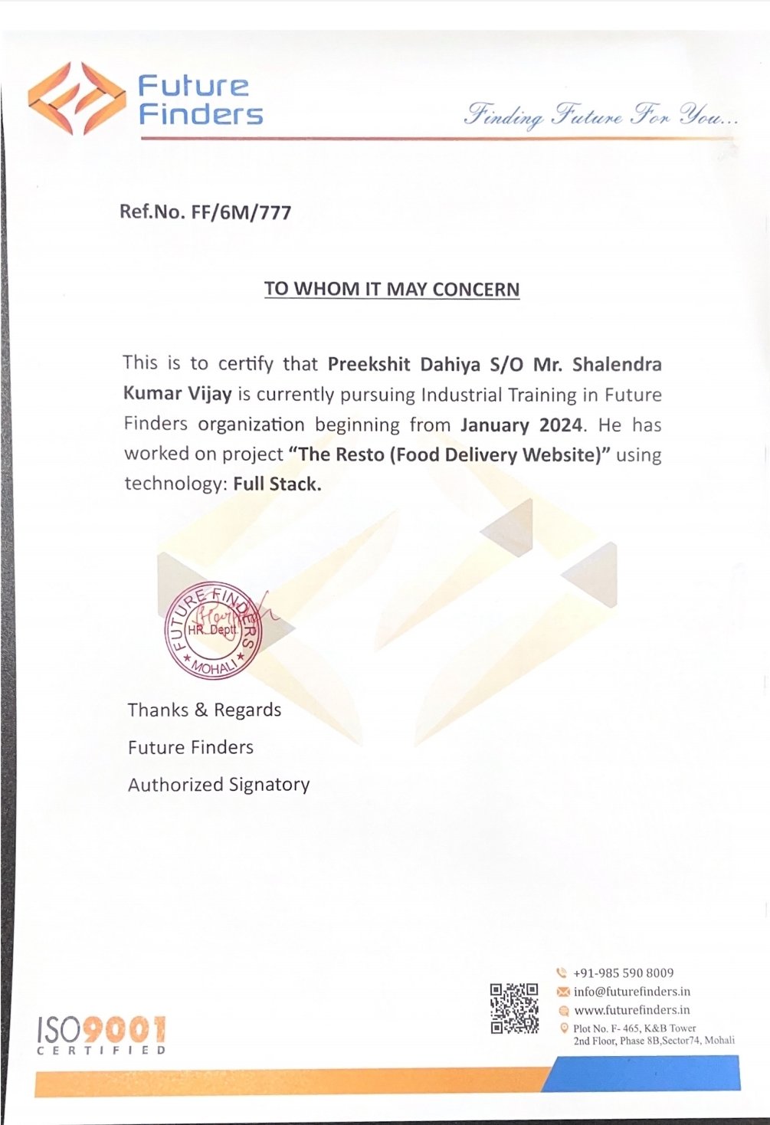

**CANDIDATE DECLARATION**

I hereby declare that the work, which is being presented in the report, entitled “**THE RESTO**” in partial fulfillment of the requirement for the award of Degree of **Bachelor of Technology** in **Computer Science & Engineering** and submitted to **CGC - College of Engineering, Landran Mohali** is an original piece of project work carried out by me during the period from January 2024 to May 2024 under the supervision of Mr. Jagbir Singh Gill.

The matter embodied in this report has not been submitted by me for the award of any other degree from any other University/Institute.

**NAME: PREEKSHIT DAHIYA**

**ROLL NO.: 2019214**

This is to certify that the above statement made by the candidate is correct to the best of my knowledge.

**Examined By:**

**1. 2. 3. 4.**

# ACKNOWLEDGEMENT:

I want to express a deep sense of gratitude for all those people who have supported me to accomplish this training project. First, I would like to thank the management of **“CHANDIGARH GROUP OF COLLEGES, LANDRAN”** who has given me the opportunity to accomplish our training for partial fulfillment of the requirement for the degree of Bachelors of Technology to I K Gujral Punjab Technical University.

Secondly, I would like to thank our parents and friends who have directly or indirectly helped us in finalizing this project within a limited time frame.

I am thankful to Mr. Jagbir Singh Gill for providing me the relevant guidance in completion of this project.

**NAME: PREEKSHIT DAHIYA**

**ROLL NO.: 2019214**

**8th semester**

**B.Tech CSE**

**ABOUT COMPANY:**

As a final semester student pursuing a degree in Computer Science & Engineering, I had the opportunity to gain valuable industry experience through a Six-month Semester Training Program with **Future Finders**. During my training, I received a certification in Full Stack, which provided me with a strong foundation in web development.

The project demanded independent effort outside of the Institute to ensure its successful completion. Future Finders is a leading Software and Web Application Development Company, based in Mohali (Chandigarh) that provides high-quality comprehensive services to enterprises across a wide range of platforms and technologies.

Future Finders is a ground breaking platform that develops young Indian talent that is motivated to advance and forge successful careers in IT.

We provide a variety of courses to help you launch your career and locate the employer that will assist you as you rise to the top. They expertise with the latest tools and techniques, and the experience of their professional experts helping in delivering high-end services to the esteemed clients.

Future Finders educates students and developers about the most recent technologies that are now popular. They are working on distributing informational know-how and offering clients specialized services following global best practices.

Their primary mission is to support technical education that is founded on values and to offer our clients the finest products and services possible.

**ABSTRACT:**

It is a food delivery website for a specially designed for the restaurant **“The Resto”.** It has a simple and responsive design. Menu driven, understandable, and user friendly interface which is compatible to use.This restaurant has its specialty in Indian foods. It Provide attractive offers on different meals.

The Proposed system is an online food ordering system that enables ease for the customers. It overcomes the disadvantages of the traditional queueing system. Our proposed system is a medium to order online food hassle free from restaurants as well as mess service. This system improves the method of taking the order from customer. The online food ordering system sets up a food menu online and customers can easily place the order as per their wish. Also with a food menu, customers can easily track the orders. This system also provides a feedback system in which user can rate the food items. Also, the proposed system can recommend food, based on the ratings given by the user, the hotel staff will be informed for the improvements along with the quality. The payment can be made online or pay-on-delivery system. For more secured ordering separate accounts are maintained for each user by providing them an ID and a password.

**TABLE OF CONTENTS:**

**CONTENT PAGE NO.**

Certificate……………………………………………………………………………….….ii.

Training Certificate….…………….……………………………………………………….iii.

Candidate Declaration..…………………………………………………………………….iv.

Acknowledgement.………………………………………………………………………....v.

About Company...………………………………………………………………………….vi.

Abstract…………………………………………………………………………………....vii.

Table of contents…………………………………………………………………………..viii.

List of Figures.……………………………………………………………………………..x.

Chapter 1: Introduction….………………………………………………………………..….1.

1.1 Overview………….……………………………………………………………….….1.

1.2 Objective………….……………………………………………………………….….1.

1.3 Scope………….….……………………………………………………………….….2.

1.4 Project Modules.….……………………………………………………………….….3.

1.4.1 UI……….….……………………………………………………………….….3.

1.4.2 Server..….….……………………………………………………………….….3.

1.5 Project Requirements……..……………………………………………………….…..3.

1.5.1 Hardware...….…………………………………………………………...….….3.

1.5.2 Software….….…………………………………………………………..…..….3.

Chapter 2: System Analysis……..………………………………………………………..…..4.

2.1 Literature Review……………………………………………………………….….….4.

2.2 Feasibility Study.…………….………………………………………………….....….5.

2.2.1 Technical Feasibility……………………………………………………...…..….5.

2.2.2 Operational Feasibility..…...……………………………………………...…..….5.

2.2.3 Legal Feasibility..……………………………………………………….…....….5.

2.2.4 Resource Feasibility..…...……………………………………………….…........5.

2.3 Project Timeline……...…………………………………………………………….....6.

2.4 Detailed Module Description with all functionalities..………...…………….……..….7.

2.4.1 UI…………………..…...……………………………………………….…......7.

2.4.2 Server..……………..…...…………………………………………………....…8.

Chapter 3: System Design………….…………………………………………………….…..9.

3.1 Use case Diagram……...…………..……………………………………………….….9.

3.2 Dataflow Diagram.…...……………………………………………………………….10.

3.3 Data Dictionary.……...……………………………………………………………….10.

Chapter 4: Software Tools……………………………………………………………….….11.

4.1 About MERN stack…...…………..………………………………………………….11.

4.1.1 Software Components…...…………………………………………………...…11.

4.1.2 Technology Stack…..…...…………………………………………………...…21.

4.1.3 Working of MERN Stack.…………………………………………………...…22.

4.1.4 Significance of MERN Stack...……………………………………………...…23.

4.2 About HTML……...…………..………………………………..……………..….….24.

4.3 About CSS……...…………..……………………………………………….……….29.

4.4 About Bootstrap……...…………..…………………………………………………..33.

4.5 About AOS……...…………..……………………………………………….………34.

Chapter 5: Implementation and testing…….…………………………………………….….37.

5.1 User Interface and Snapshots……..………………………………………………….40.

5.2 Test Cases and Result……………..……………………………………………….…44.

Chapter 6: Conclusion…….…………………………………….……………………….…..49.

References…….………………………………………………………..…………….…..51.

**LIST OF FIGURES:**

**CONTENT PAGE NO.**

Figure1. Process of Online Food Ordering …….……………………………………...….1.

Figure2. Benefits of Online Food Ordering …………………………………………..…..2.

Figure3. Process of Project Development ...…………………………………………...….6.

Figure4. Use case Diagram………...…………………………………………………...….9.

Figure5. Data Flow Diagram……………………………………………………….….….10.

Figure6. Data Dictionary ….………………………………………………………….….10.

Figure7. Technology stack……………………………………………………….……….21.

Figure8. Tiers of MERN project……..….…………………………………………..…....22.

Figure9. User Interface and Snapshots.….………………………………………….…….40.

Figure10. Test cases and results………….……………………………………….…...….44.

Figure11. Tracking the delivery……………………………………………………….….50.

**CHAPTER 1. INTRODUCTION:**

**1.1 Overview**

This website is made to provide the service of online food ordering and delivery to the customers of the restaurant named “The Resto”. It contain various web-pages serving various purposes (Home, Menu, Offers, Login, Contact and About).

Its home page also contains the special meals of the restaurant providing extra attraction to the customers. It is made to attract the customers rather than to distribute the customers which enhance the business much effectively.

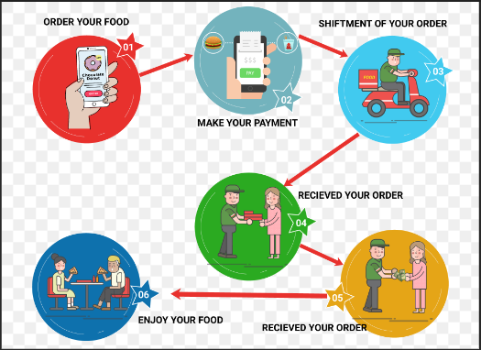

Fig.1.Process of Online Food Ordering

**1.2 Objective**

This website is made with the objective to provide Food delivery system for the specific restaurant named “The Resto”.

With this platform users can easily order for their foods without much difficulty. Rather than focusing on general and combined business it focuses on specific one. It is made to attract the customers rather than to distribute the customers which enhance the business much effectively.

**1.3 Scope**

This website has a great scope in Restaurant market where it only focuses on single motive to attract customers. Its objective to not distribute customers make more beneficial for business in this field. With decrease in distribution of customers it can focus only on one goal to increase the number of customers.

With this platform users can easily order for their foods without much difficulty. Rather than focusing on general and combined business it focuses on specific one.

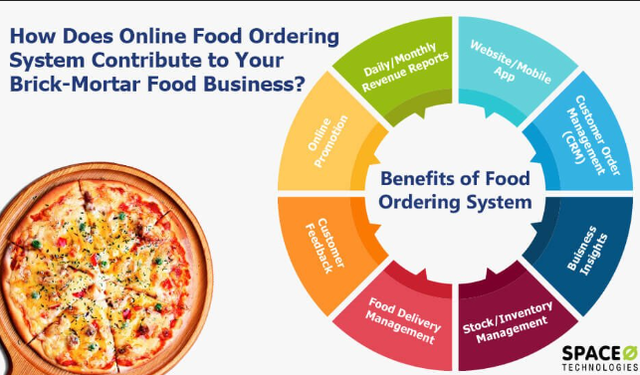

Fig.2.Benefits of Online Food Ordering

**1.4Project Modules**

**1.4.1 UI**

This defines the user interface of the website. In this modules frontend related functionalities are given, containing different pages like home, menu, offers, contact and about us.

**1.4.2Server**

This defines the backend functionalities of the website. In this module, functionalities like storing data in the database, storing feedback and other messages, storing login data are given.

**1.5Project Requirements**

**1.5.1 Hardware**

**->**Processor: 10th Gen Intel core i5.

**->**Processor speed: 2.42GHz.

**->**Windows 10 or above.

**->**RAM: 2.00GB or above.

**->**System type: 64-bit operating system.

**->**Internet connection: any type.

**1.5.2 Software**

**->** Browser: Google Chrome.

**->**Operating system: Run in every OS.

**->** Front End: React JS/Bootstrap/Html/CSS.

**->** Back End: Node JS/ Express.

**->** IDE used: Visual Studio Code.

**->**Database used: MongoDB.

**->**Runs project on: NPM (Node Package Manager) for the Node JavaScript platform.

**CHAPTER 2. SYSTEM ANALYSIS: 2.1Literature review**

In accordance with scholarly article of National Center for Biotechnology Information, there was not much research conducted on the OFD (Online Food delivery) area before the COVID-19 pandemic. Previous studies have mainly focused on issues such as the OFD platform's performance and customer satisfaction, consumer’s behavior and attitude, vehicle routing problems, adoption and acceptance of technology in OFD apps, and rider’s issues related to wages and health.

Research on the OFD has witnessed significant growth during the last two years. One of the reasons for this rapid growth was the rapid increase in OFD services demand during the COVID-19 pandemic. For safety reasons, more people started ordering their food from home via OFD apps.

India is one of the most populated countries and was severely affected by the COVID-19. Several studies have been conducted to understand OFD companies and customers' purchase behaviors in the Indian market. It was found that Zomato received the most positive and less negative customer sentiments than other competitors, such as Swiggy in India. The food quality and safety measure of OFDAs positively affects customer satisfaction and loyalty in India. It was investigated student satisfaction and loyalty to OFDAs. Their findings suggest that satisfaction is the main predictor of loyalty, whereas mobile app information design has the highest impact on satisfaction and loyalty. Chen McCain et al. (2021) assessed customers' satisfaction with Uber Eats on different dimensions—OFD apps performance, food quality, and service quality during the first wave of COVID-19 in the US. They found that service quality was the most important dimension, followed by OFD app performance and food quality.

The second set of studies focused on the continuous usage intention of OFD apps during the COVID-19 outbreak period in different countries, such as India, USA, China, Brazil, Mexico, Vietnam. These and several other studies have found that performance expectancy, habit, effort expectancy, price saving orientation, perceived usefulness, and employee trust affect consumers intention to use OFD services during the COVID-19 period.

Similarly, delivery, hygiene, subjective norms, attitudes, behavioral control, and social isolation positively affect the consumers' continuance intention to use Mobile food delivery apps. Further, studies have also found that OFD apps features, ease of use, convenience, price saving, and food variety also affect the continued intention to use the FDA. It was found that customers preferred innovative solutions by OFD companies during COVID-19. It was observed that the app aesthetics were responsible for customers' pleasure, significantly affecting the customers' continued usage intent.

**2.2Feasibility Study**

**2.2.1 Technical Feasibility**

In Technical Feasibility, current resources both hardware and software along with required technologies are analyzed/assessed to develop this project. This study gives report that there exist correct required resources and technologies which will be used for project development.

**2.2.2** **Operational Feasibility**

In Operational Feasibility, degree of providing service to requirements is analyzed which shows that the product will be easy to operate and maintenance after deployment. This studies other operational scopes determining usability of product, determining suggested solution by developer is acceptable.

**2.2.3Legal Feasibility**

In Legal Feasibility study, project is analyzed in legality point of view. This includes analyzing barriers of legal implementation of project, data protection acts or social media laws, project certificate, license, copyright etc. Overall it can be said that proposed project conform legal and ethical requirements.

**2.2.4Resource Feasibility**

This method evaluates if the resources needed to complete this project successfully are adequate and readily available. Financial, technological and human resources are all taken into account in this study. This study guarantees that sufficient hardware, software; trained labour and funding are available to complete the project successfully.

**2.3Project Timeline**

* **Phase 1 (Pre-Development):** In this phase, Objective and requirements are understood along with doing planning. Then Feasibility of this project is calculated with different aspects like technology and operation.
* **Phase 2 ( Development ):** This phase is divided into two sub-phases:
  + Frontend Development: This phase is completed by creating the responsive UI.
  + Backend Development: This phase is completed by defining server functionalities.

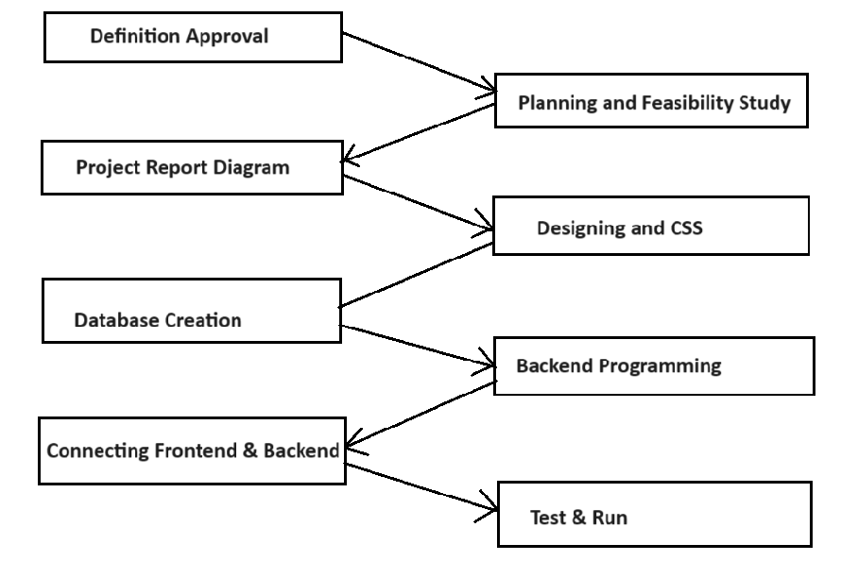

Fig.3.Process of Project Development

**2.4Detailed Module Description with all Functionalities**

**2.4.1 UI**

This defines the user interface of the website. In this modules frontend related functionalities are given, containing different pages like home, menu, offers, contact and about us.

This further includes following components:

**Navbar**

It contains the logo and the navigation links of the website. It also contains the search form which will search your favorite meals in the website. Also after login it will show the user name and logout button to navigate the user in its account.

**Home**

It contains the carousel class of bootstrap library which will show the three outstanding specialties to attract the customer. Then it goes to the cards component.

**Cards**

This component contains the special dishes of the restaurant which are animated using aos library.

Using its subcomponent (Card) and props it designs eight special dishes to attract special attention.

**Footer**

It contains the information of the owner and copyright statement to preserve its right. Further it gives information about the owner like address and email. Also it contains the navigation links along with a form for the feedback message from the customer.

**Menu**

It contains the main menu of the restaurant which includes main course, staples, snacks, sweets and desserts along with their price.

**Login**

It contains a toggle button for login of the user. After clicking on the login button, a side-panel will open for login form comprising username and password. This user login is authenticated with jwt and checks the user authentication. Further it contains the navigation link to register component for user registration.

**Registration**

This component includes a registration form for new users.to the website. It takes user information like username, email, password and sends it to the server.

**Offers**

It contains the various attracting offers on different deals and also a special offer to first time users.

**Contact**

This component gives owner information and contact details like address, contact number, email, websites etc. to the users. Further, it contains a form for user contact.

**About Us**

This component is made to tell the user about the restaurant.

**2.4.2Server**

This defines the backend functionalities of the website. In this module, functionalities like storing data in the database, storing feedback and other messages, storing login data are given.

This module contains following components:

**Index**

It is the main component of the server containing various routes connecting database and user interface. This component takes data send by the frontend components and save it to the database. Entire backend functionality depends on this single component only.

**Models**

This component defines the schema and model for the database storage.

This concludes the detailed description of the project modules.

**CHAPTER 3. SYSTEM DESIGN:**

**3.1Use case Diagram**

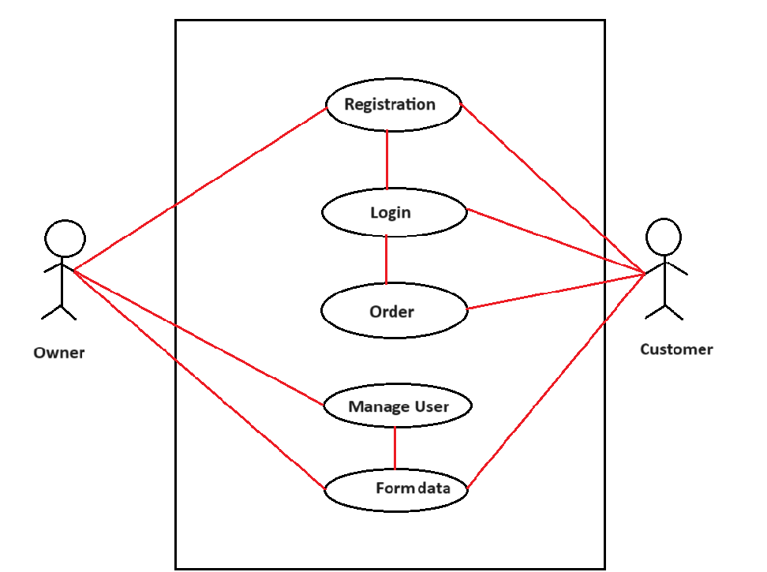

Fig.4. Use case Diagram

This diagram is trying to show how user interacts with the system.

**3.2Data flow Diagram**

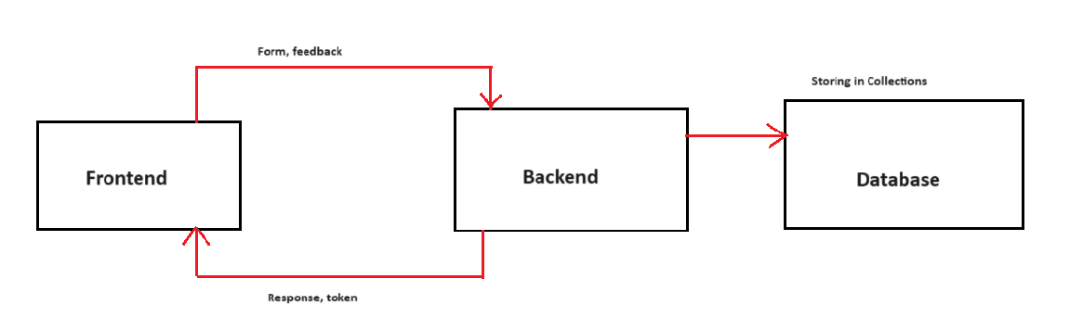

Fig.5. Data Flow Diagram

**3.3Data Dictionary**

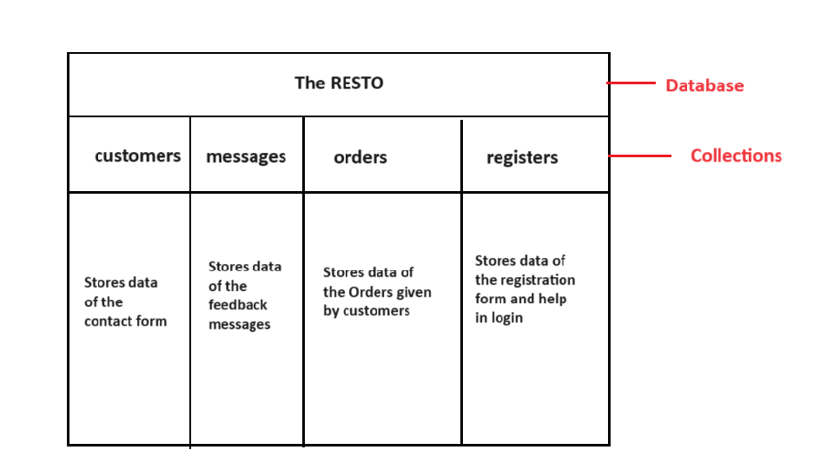

Fig.6. Data Dictionary

**CHAPTER 4. SOFTWARE TOOLS:**

**4.1About MERN stack**

**MERN** stack is a software stack that includes four open-source technologies: (MongoDB, Express.js, React, and Node.js). These components provide an end-to-end framework for building dynamic web sites and web applications.

Among these technologies MongoDB is a database system, Node.js is a server-side runtime environment, Express.js is a web framework for Node.js and React is a client-side JavaScript library used for building user interfaces.

Because all components of the MERN stack support programs that are written in JavaScript, MERN applications can be written in one programming language for both server-side and client-side execution environments.

**4.1.1Software Components**

**MongoDB**

MongoDB is a NoSQL database program that uses JSON-like BSON (binary JSON) documents with schema.

The role of the database in the MERN stack is very commonly filled by MongoDB because its use of JSON-like documents for interacting with data as opposed to the row/column model allows it to integrate well with the other (JavaScript-based) components of the stack.

**Main features**

->Ad-hoc queries

MongoDB supports field, range query and regular-expression searches. Queries can return specific fields of documents and also include user-defined JavaScript functions. Queries can also be configured to return a random sample of results of a given size.

->Indexing

Fields in a MongoDB document can be indexed with primary and secondary indices.

->Replication

MongoDB provides high availability with replica sets. A replica set consists of two or more copies of the data. Each replica-set member may act in the role of primary or secondary replica at any time. All writes and reads are done on the primary replica by default. Secondary replicas maintain a copy of the data of the primary using built-in replication. When a primary replica fails, the replica set automatically conducts an election process to determine which secondary should become the primary. Secondaries can optionally serve read operations, but that data is only eventually consistent by default.

If the replicated MongoDB deployment only has a single secondary member, a separate daemon called an arbiter must be added to the set. It has the single responsibility of resolving the election of the new primary. As a consequence, an ideal distributed MongoDB deployment requires at least three separate servers, even in the case of just one primary and one secondary.

->Load balancing

MongoDB scales horizontally using sharding. The user chooses a shard key, which determines how the data in a collection will be distributed. The data is split into ranges (based on the shard key) and distributed across multiple shards, which are masters with one or more replicas. Alternatively, the shard key can be hashed to map to a shard–enabling an even data distribution.

MongoDB can run over multiple servers, balancing the load or duplicating data to keep the system functional in case of hardware failure.

->File storage

MongoDB can be used as a file system, called GridFS, with load-balancing and data-replication features over multiple machines for storing files.

This function, called a grid file system, is included with MongoDB drivers. MongoDB exposes functions for file manipulation and content to developers. GridFS can be accessed using the mongofiles utility or plugins for Nginx and lighttpd. GridFS divides a file into parts, or chunks, and stores each of those chunks as a separate document.

->Aggregation

MongoDB provides three ways to perform aggregation: the aggregation pipeline, the map-reduce function and single-purpose aggregation methods.

Map-reduce can be used for batch processing of data and aggregation operations. However, according to MongoDB's documentation, the aggregation pipeline provides better performance for most aggregation operations.

The aggregation framework enables users to obtain results similar to those returned by queries that include the SQL GROUP BY clause. Aggregation operators can be strung together to form a pipeline, analogous to Unix pipes. The aggregation framework includes the $lookup operator, which can join documents from multiple collections, as well as statistical operators such as standard deviation.

->Server-side JavaScript execution

JavaScript can be used in queries, aggregation functions (such as MapReduce) and sent directly to the database to be executed.

->Capped collections

MongoDB supports fixed-size collections called capped collections. This type of collection maintains insertion order and, once the specified size has been reached, behaves like a circular queue.

->Transactions

MongoDB supports multi-document ACID transactions since the 4.0 release in June 2018.

**Editions**

->MongoDB Community Server

The MongoDB Community Edition is free and available for Windows, Linux and macOS.

->MongoDB Enterprise Server

MongoDB Enterprise Server is the commercial edition of MongoDB and is available as part of the MongoDB Enterprise Advanced subscription.

->MongoDB Atlas

MongoDB is also available as an on-demand, fully managed service. MongoDB Atlas runs on AWS, Microsoft Azure and Google Cloud Platform.

**Express.js**

Express.js (also referred to as Express) is a modular web application framework for Node.js.

Whilst Express is capable of acting as an internet-facing web server, even supporting SSL/TLS out of the box, it is often used in conjunction with a reverse proxy such as NGINX or Apache for performance reasons.

**Features**

->Robust routing.

->Concentrate on high-performance.

->HTTP helpers (redirection, caching, etc...).

->Asynchronous programming.

**React**

React (also known as React.js or ReactJS) is a JavaScript library for building user interfaces. It is maintained by Facebook and a community of individual developers and companies.

React can be used as a base in the development of single-page or mobile applications. However, React is only concerned with rendering data to the DOM, and so creating React applications usually requires the use of additional libraries for state management and routing. Redux and React Router are respective examples of such libraries.

**Notable features**

->Declarative

React adheres to the declarative programming paradigm. Developers design views for each state of an application, and React updates and renders components when data changes. This is in contrast with imperative programming.

->Components

React code is made of entities called components. These components are modular and reusable. React applications typically consist of many layers of components. The components are rendered to a root element in the DOM using the React DOM library. When rendering a component, values are passed between components through props (short for "properties"). Values internal to a component are called its state.

The two primary ways of declaring components in React are through function components and class components.

->Function components

Function components are declared with a function (using JavaScript function syntax or an arrow function expression) that accepts a single "props" argument and returns JSX. From React v16.8 onwards, function components can use state with the useState Hook.->React Hooks

On February 16, 2019, React 16.8 was released to the public, introducing React Hooks. Hooks are functions that let developers "hook into" React state and lifecycle features from function components. Notably, Hooks do not work inside classes — they let developers use more features of React without classes.

React provides several built-in hooks such as useState,  useContext, useReducer, useMemo  and useEffect  Others are documented in the Hooks API Reference  useState and useEffect, which are the most commonly used, are for controlling state and side effects,  respectively.

->Rules of hooks

There are two rules of hooks which describe the characteristic code patterns that hooks rely on:

1. "Only call hooks at the top level" — don't call hooks from inside loops, conditions, or nested statements so that the hooks are called in the same order each render.

2. "Only call hooks from React functions" — don't call hooks from plain JavaScript functions so that stateful logic stays with the component.

Although these rules can't be enforced at runtime, code analysis tools such as linters can be configured to detect many mistakes during development. The rules apply to both usage of Hooks and the implementation of custom Hooks, which may call other Hooks.

->Server components

React server components or "RSC"s are function components that run exclusively on the server. The concept was first introduced in the talk Data Fetching with Server Components Though a similar concept to Server Side. Rendering, RSCs do not send corresponding JavaScript to the client as no hydration occurs. As a result, they have no access to hooks. However, they may be asynchronous function, allowing them to directly perform asynchronous operations:

->Class components

Class components are declared using ES6 classes. They behave the same way that function components do, but instead of using Hooks to manage state and lifecycle events, they use the lifecycle methods on the React.Component base class.

->Routing

React itself does not come with built-in support for routing. React is primarily a library for building user interfaces, and it doesn't include a full-fledged routing solution out of the box. Third-party libraries can be used to handle routing in React applications. It allows the developer to define routes, manage navigation, and handle URL changes in a React-friendly

->Virtual DOM

Another notable feature is the use of a virtual Document Object Model, or Virtual DOM. React creates an in-memory data-structure cache, computes the resulting differences, and then updates the browser's displayed DOM efficiently. This process is called reconciliation. This allows the programmer to write code as if the entire page is rendered on each change, while React only renders the components that actually change. This selective rendering provides a major performance boost.

**Node.js**

Node.js is the application runtime that the MERN stack runs on.

The use of Node.js, which is said to represent a "JavaScript Everywhere" paradigm, is integral to the MERN stack which relies on that concept.

Node.js allows the creation of web servers and networking tools using JavaScript and a collection of "modules" that handle various core functionalities. Modules are provided for file system I/O, networking (DNS, HTTP, TCP, TLS/SSL or UDP), binary data (buffers), cryptography functions, data streams and other core functions. Node.js's modules use an API designed to reduce the complexity of writing server applications.

JavaScript is the only language that Node.js supports natively, but many compile-to-JS languages are available. As a result, Node.js applications can be written in CoffeeScript, Dart, TypeScript, ClojureScript and others.

Node.js is primarily used to build network programs such as web servers. The most significant difference between Node.js and PHP is that most functions in PHP block until completion (commands execute only after previous commands finish), while Node.js functions are non-blocking (commands execute concurrently or even in parallel, and use callbacks to signal completion or failure).

Node.js is officially supported by Linux, macOS and Microsoft Windows 8.1 and Server 2012 (and later), with Tier 2 support for SmartOS and IBM AIX and experimental support for FreeBSD. OpenBSD also works, and LTS versions are available for IBM i (AS/400). The source code may also be built on similar operating systems that are not officially supported, such as NonStop OS and Unix servers.

**Platform architecture**

Node.js enables development of fast web servers in JavaScript using event-driven programming. Developers can create scalable servers without using threading by using a simplified model that uses callbacks to signal the completion of a task. Node.js connects the ease of a scripting language (JavaScript) with the power of Unix network programming.

Node.js was built on top of Google's V8 JavaScript engine since it was open-sourced under the BSD license, and it contains comprehensive support for fundamental protocols such as HTTP, DNS and TCP. JavaScript's existing popularity made Node.js accessible to the web-development community.

**Industry support**

There are thousands of open-source libraries for Node.js, most of which are hosted on the npm website. Multiple developer conferences and events are held that support the Node.js community, including NodeConf, Node Interactive and Node Summit, as well as a number of regional events.

The open-source community has developed web frameworks to accelerate the development of applications. Such frameworks include Express.js, Socket.IO, Sails.js, Next.js and Meteor. Various packages have also been created for interfacing with other languages or runtime environments such as Microsoft .NET.

Modern desktop IDEs provide editing and debugging features specifically for Node.js applications. Such IDEs include Atom, Brackets, JetBrains WebStorm, and Microsoft Visual Studio (with Node.js Tools for Visual Studio, or TypeScript with Node definitions, NetBeans, Nodeclipse Enide Studio (Eclipse-based) and Visual Studio Code Some online IDEs also support Node.js, such as Codeanywhere, Eclipse Che, Cloud9 IDE and the visual flow editor in Node-RED.

Node.js is supported across a number of cloud-hosting platforms such as Jelastic, Google Cloud Platform, AWS Elastic Beanstalk, Azure Web Apps and Joyent.

**Technical details**

Node.js is a JavaScript runtime environment that processes incoming requests in a loop, called the event loop.

**Internals**

Node.js uses libuv under the hood to handle asynchronous events. Libuv is an abstraction layer for network and file system functionality on both Windows and POSIX-based systems such as Linux, macOS, OSS on NonStop, and Unix. Node.js relies on nghttp2 for HTTP support. As of version 20, Node.js uses the ada library which provides up-to-date WHATWG URL compliance. As of version 19.5, Node.js uses the simdutf library for fast Unicode validation and transcoding. As of version 21.3, Node.js uses the simdjson library for fast JSON parsing.

**Threading**

Node.js operates on a single-thread event loop, using non-blocking I/O calls, allowing it to support tens of thousands of concurrent connections without incurring the cost of thread context switching. The design of sharing a single thread among all the requests that use the observer pattern is intended for building highly concurrent applications, where any function performing I/O must use a callback. To accommodate the single-threaded event loop, Node.js uses the libuv library—which, in turn, uses a fixed-sized thread pool that handles some of the non-blocking asynchronous I/O operations.

A thread pool handles the execution of parallel tasks in Node.js. The main thread function call posts tasks to the shared task queue, which threads in the thread pool pull and execute. Inherently non-blocking system functions such as networking translate to kernel-side non-blocking sockets, while inherently blocking system functions such as file I/O run in a blocking way on their own threads. When a thread in the thread pool completes a task, it informs the main thread of this, which in turn, wakes up and executes the registered callback.

A downside of this single-threaded approach is that Node.js does not allow vertical scaling by increasing the number of CPU cores of the machine it is running on without using an additional module, such as cluster, StrongLoop Process Manager,or pm2. However, developers can increase the default number of threads in the libuv thread pool. The server operating system (OS) is likely to distribute these threads across multiple cores. Another problem is that long-lasting computations and other CPU-bound tasks freeze the entire event-loop until completion.[citation needed]

**V8**

V8 is the JavaScript execution engine which was initially built for Google Chrome. It was then open-sourced by Google in 2008. Written in C++, V8 compiles JavaScript source code to native machine code at runtime. As of 2016, it also includes Ignition, a bytecode interpreter.

**Package management**

npm is the pre-installed package manager for the Node.js server platform. It installs Node.js programs from the npm registry, organizing the installation and management of third-party Node.js programs.

**Event loop**

Node.js registers with the operating system so the OS notifies it of asynchronous I/O events such as new connections. Within the Node.js runtime, events trigger callbacks and each connection is handled as a small heap allocation. Traditionally, relatively heavyweight OS processes or threads handled each connection. Node.js uses an event loop for concurrent I/O, instead of processes or threads. In contrast to other event-driven servers, Node.js's event loop does not need to be called explicitly. Instead, callbacks are defined, and the server automatically enters the event loop at the end of the callback definition. Node.js exits the event loop when there are no further callbacks to be performed.

**WebAssembly**

Node.js supports WebAssembly and as of Node 14 has experimental support of WASI, the WebAssembly System Interface.

**Native bindings**

Node.js provides a way to create "add-ons" via a C-based API called N-API, which can be used to produce loadable (importable) .node modules from source code written in C/C++. The modules can be directly loaded into memory and executed from within JS environment as simple CommonJS modules. The implementation of the N-API relies on internal C/C++ Node.js and V8 objects requiring users to import (#include) Node.js specific headers into their native source code.

As the Node.js API is subject to breaking changes at a binary level, modules have to be built and shipped against specific Node.js versions to work properly. To address the issue, third parties have introduced open-sourced С/С++ wrappers on top of the API that partially alleviate the problem. They simplify interfaces, but as a side effect they may also introduce complexity which maintainers have to deal with. Even though the core functionality of Node.js resides in a JavaScript built-in library, modules written in C++ can be used to enhance capabilities and to improve performance of applications.

**4.1.2Technology Stack**

Before further diving into the MERN stack, let's quickly understand what a technology stack is. A technology stack is a set of technologies you choose and use to build a web application, mobile application or similar applications. A good technology stack must give a seamless user experience as well as be scalable and cost-effective. A typical tech stack contains a frontend, backend and database and is known as a full technology stack.

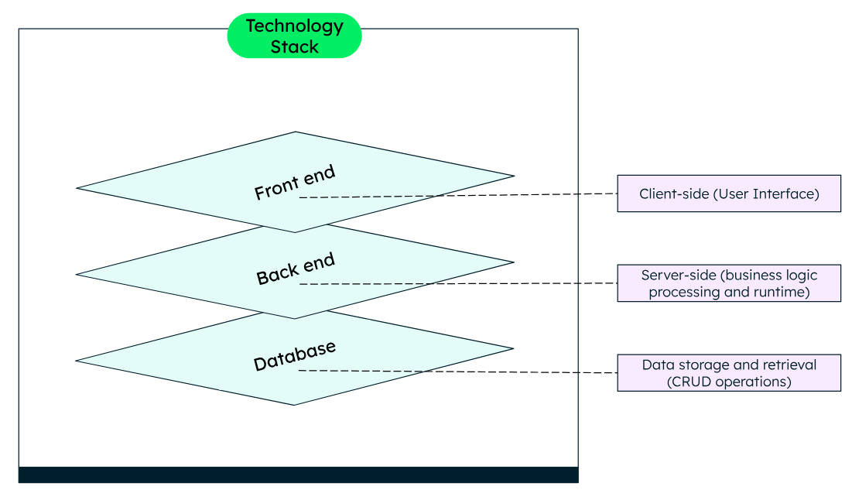

Fig.7. Technology stack

Usually, the basic front-end or user interface technologies remain the same, i.e., HTML, CSS and JavaScript. Depending on the project requirements, you can use libraries and frameworks, like React or Angular, which are built upon these UI technologies.

Back-end consists of a server, where your application logic resides. You can write the application logic in one or more programming languages like JavaScript, Java, Python, or use frameworks like Django, Spring, and Express.js. To execute the programs, your application needs a runtime like Node.js, JRE (Java Runtime Environment).

The database is the storage hub, where all the application related data is stored. You can choose to store your data in a tabular structure (using relational database systems), or using non-relational, also called NoSQL, such as document structure, graph structure and so on and select the database accordingly. Some examples of databases are MongoDB, Oracle, and MySQL.

**4.1.3Working of MERN stack**

The MERN architecture allows you to easily construct a three-tier architecture (front end, back end, database) entirely using JavaScript and JSON.

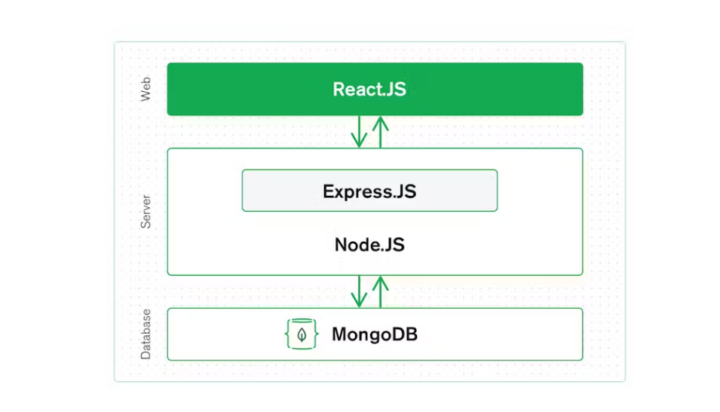

Fig.8. Tiers in MERN project

**React.js frontend tier**

The top tier of the MERN stack is React.js, the declarative JavaScript framework for creating dynamic client-side applications in HTML. React lets you build complex interfaces through simple components, connect them to data on your back-end server, and render them as HTML.

React's strong suit is handling stateful, data-driven interfaces with minimal code and hassle, and it has all the features you'd expect from a modern web framework: great support for forms, error handling, events, lists, and more.

**Express.js and Node.js server tier**

The next level down is the Express.js server-side framework, running inside a Node.js server. Express.js bills itself as a “fast, unopinionated, minimalist web framework for Node.js,” and that is indeed exactly what it is. Express.js has powerful models for URL routing (matching an incoming URL with a server function), and handling HTTP requests and responses.

By making XML HTTP Requests (XHRs), GETs, or POSTs from your React.js front end, you can connect to Express.js functions that power your application. Those functions, in turn, use MongoDB's Node.js drivers, to access and update data in your MongoDB database.

**MongoDB database tier**

If your application stores any data (user profiles, content, comments, uploads, events, etc.), then you're going to want a database that's just as easy to work with as React, Express, and Node.js.

That's where MongoDB comes in: JSON documents created in your React.js front end can be sent to the Express.js server, where they can be processed and (assuming they're valid) stored directly in MongoDB for later retrieval. Again, if you're building in the cloud, you'll want to look at MongoDB Atlas.

**4.1.4Significance of MERN stack**

Let's start with MongoDB, the document database at the root of the MERN stack. MongoDB was designed to store JSON data natively. (It technically uses a binary version of JSON called BSON.) Everything from its command line interface to its query language is built on JSON and JavaScript.

MongoDB works extremely well with Node.js, and makes storing, manipulating, and representing JSON data at every tier of your application incredibly easy. For cloud-native applications,

MongoDB Atlas makes it even easier by giving you an auto-scaling MongoDB cluster on the cloud provider of your choice with just a few button clicks.

Express.js (running on Node.js) and React.js make the JavaScript/JSON application MERN full stack, well, full. Express.js is a server-side application framework that wraps HTTP requests and responses and makes it easy to map URLs to server-side functions. React.js is a front-end JavaScript framework for building interactive user interfaces in HTML and communicating with a remote server.

The combination means that JSON data flows naturally from front to back, making it easier to build on and reasonably simple to debug. Plus, you only have to know one programming language, and the JSON document structure, to understand the whole system!

MERN is the stack of choice for today's web developers looking to move quickly, particularly for those with React.js experience.

**4.2About HTML**

HTML (Hyper Text Markup Language) is a language used to create hypertext documents that have hyperlinks embedded in them. It consists of tags embedded in the text of a document with HTML.

We can build web pages or web document s. it is basically a formatting language and not a programming language. The browser reading the document interprets markup tags to help format the document for subsequent display to a reader. HTML is a language for describing structure documents. HTML is a platform independent. WWW (World Wide Web) pages are written using HTML. HTML tags control in part the representation of the WWW page when view with webbrowser.

HTML elements are the building blocks of HTML pages. With HTML constructs, images and other objects such as interactive forms may be embedded into the rendered page. HTML provides a means to create structured documents by denoting structural semantics for text such as headings, paragraphs, lists, links, quotes, and other items. HTML elements are delineated by tags, written using angle brackets. Tags such as <img> and <input> directly introduce content into the page. Other tags such as <p> and </p> surround and provide information about document text and may include sub-element tags. Browsers do not display the HTML tags but use them to interpret the content of the page.

HTML can embed programs written in a scripting language such as JavaScript, which affects the behaviour and content of web pages. The inclusion of CSS defines the look and layout of content. The World Wide Web Consortium (W3C), former maintainer of the HTML and current maintainer of the CSS standards, has encouraged the use of CSS over explicit presentational HTML since 1997. A form of HTML, known as HTML5, is used to display video and audio, primarily using the <canvas> element, together with JavaScript.

**Markup**

HTML markup consists of several key components, including those called tags (and their attributes), character-based data types, character references and entity references. HTML tags most commonly come in pairs like <h1> and </h1>, although some represent empty elements and so are unpaired, for example <img>. The first tag in such a pair is the start tag, and the second is the end tag (they are also called opening tags and closing tags).

Another important component is the HTML document type declaration, which triggers standards mode rendering.

**Elements**

HTML documents imply a structure of nested HTML elements. These are indicated in the document by HTML tags, enclosed in angle brackets thus: <p>.

In the simple, general case, the extent of an element is indicated by a pair of tags: a "start tag" <p> and "end tag" </p>. The text content of the element, if any, is placed between these tags.

Tags may also enclose further tag markup between the start and end, including a mixture of tags and text. This indicates further (nested) elements, as children of the parent element.

The start tag may also include the element's attributes within the tag. These indicate other information, such as identifiers for sections within the document, identifiers used to bind style information to the presentation of the document, and for some tags such as the <img> used to embed images, the reference to the image resource in the format like this: <img src="example.com/example.jpg">

Some elements, such as the line break <br> do not permit any embedded content, either text or further tags. These require only a single empty tag (akin to a start tag) and do not use an end tag.

Many tags, particularly the closing end tag for the very commonly used paragraph element <p>, are optional. An HTML browser or other agent can infer the closure for the end of an element from the context and the structural rules defined by the HTML standard. These rules are complex and not widely understood by most HTML authors.

The general form of an HTML element is therefore: <tag attribute1="value1" attribute2="value2">''content''</tag>. Some HTML elements are defined as empty elements and take the form <tag attribute1="value1" attribute2="value2">. Empty elements may enclose no content, for instance, the <br> tag or the inline <img> tag. The name of an HTML element is the name used in the tags. The end tag's name is preceded by a slash character, /, and that in empty elements the end tag is neither required nor allowed. If attributes are not mentioned, default values are used in each case.

**Semantic HTML**

Semantic HTML is a way of writing HTML that emphasizes the meaning of the encoded information over its presentation (look). HTML has included semantic markup from its inception, but has also included presentational markup, such as <font>, <i> and <center> tags. There are also the semantically neutral div and span tags. Since the late 1990s, when Cascading Style Sheets were beginning to work in most browsers, web authors have been encouraged to avoid the use of presentational HTML markup with a view to the separation of content and presentation.

In a 2001 discussion of the Semantic Web, Tim Berners-Lee and others gave examples of ways in which intelligent software "agents" may one day automatically crawl the web and find, filter, and correlate previously unrelated, published facts for the benefit of human users. Such agents are not commonplace even now, but some of the ideas of Web 2.0, mashups and price comparison websites may be coming close. The main difference between these web application hybrids and Berners-Lee's semantic agents lies in the fact that the current aggregation and hybridization of information is usually designed by web developers, who already know the web locations and the API semantics of the specific data they wish to mash, compare and combine.

An important type of web agent that does crawl and read web pages automatically, without prior knowledge of what it might find, is the web crawler or search-engine spider. These software agents are dependent on the semantic clarity of web pages they find as they use various techniques and algorithms to read and index millions of web pages a day and provide web users with search facilities without which the World Wide Web's usefulness would be greatly reduced.

In order for search engine spiders to be able to rate the significance of pieces of text they find in HTML documents, and also for those creating mashups and other hybrids as well as for more automated agents as they are developed, the semantic structures that exist in HTML need to be widely and uniformly applied to bring out the meaning of the published text.

Presentational markup tags are deprecated in current HTML and XHTML recommendations. The majority of presentational features from previous versions of HTML are no longer allowed as they lead to poorer accessibility, higher cost of site maintenance, and larger document sizes.

Good semantic HTML also improves the accessibility of web documents (see also Web Content Accessibility Guidelines). For example, when a screen reader or audio browser can correctly ascertain the structure of a document, it will not waste the visually impaired user's time by reading out repeated or irrelevant information when it has been marked up correctly.

**Delivery**

HTML documents can be delivered by the same means as any other computer file. However, they are most often delivered either by HTTP from a web server or by email.

**HTTP**

Main article: Hypertext Transfer Protocol

The World Wide Web is composed primarily of HTML documents transmitted from web servers to web browsers using the Hypertext Transfer Protocol (HTTP). However, HTTP is used to serve images, sound, and other content, in addition to HTML. To allow the web browser to know how to handle each document it receives, other information is transmitted along with the document. This meta data usually includes the MIME type (e.g., text/html or application/xhtml+xml) and the character encoding (see Character encoding in HTML).

In modern browsers, the MIME type that is sent with the HTML document may affect how the document is initially interpreted. A document sent with the XHTML MIME type is expected to be well-formed XML; syntax errors may cause the browser to fail to render it. The same document sent with the HTML MIME type might be displayed successfully since some browsers are more lenient with HTML.

The W3C recommendations state that XHTML 1.0 documents that follow guidelines set forth in the recommendation's Appendix C may be labeled with either MIME Type. XHTML 1.1 also states that XHTML 1.1 documents should be labeled with either MIME type.

**HTML e-mail**

Main article: HTML email

Most graphical email clients allow the use of a subset of HTML (often ill-defined) to provide formatting and semantic markup not available with plain text. This may include typographic information like colored headings, emphasized and quoted text, inline images and diagrams. Many such clients include both a GUI editor for composing HTML e-mail messages and a rendering engine for displaying them. Use of HTML in e-mail is criticized by some because of compatibility issues, because it can help disguise phishing attacks, because of accessibility issues for blind or visually impaired people, because it can confuse spam filters and because the message size is larger than plain text.

**Naming conventions**

The most common filename extension for files containing HTML is .html. A common abbreviation of this is .htm, which originated because some early operating systems and file systems, such as DOS and the limitations imposed by FAT data structure, limited file extensions to three letters.

**HTML Application**

An HTML Application (HTA; file extension .hta) is a Microsoft Windows application that uses HTML and Dynamic HTML in a browser to provide the application's graphical interface. A regular HTML file is confined to the security model of the web browser's security, communicating only to web servers and manipulating only web page objects and site cookies. An HTA runs as a fully trusted application and therefore has more privileges, like creation/editing/removal of files and Windows Registry entries. Because they operate outside the browser's security model, HTAs cannot be executed via HTTP, but must be downloaded (just like an EXE file) and executed from local file system.

**4.3About CSS**

Cascading Style Sheets (CSS) is a style sheet language used for specifying the presentation and styling of a document written in a markup language such as HTML or XML (including XML dialects such as SVG, MathML or XHTML). CSS is a cornerstone technology of the World Wide Web, alongside HTML and JavaScript.

CSS is designed to enable the separation of content and presentation, including layout, colors, and fonts. This separation can improve content accessibility provide more flexibility and control in the specification of presentation characteristics; enable multiple web pages to share formatting by specifying the relevant CSS in a separate .css file, which reduces complexity and repetition in the structural content; and enable the .css file to be cached to improve the page load speed between the pages that share the file and its formatting.

Separation of formatting and content also makes it feasible to present the same markup page in different styles for different rendering methods, such as on-screen, in print, by voice (via speech-based browser or screen reader), and on Braille-based tactile devices. CSS also has rules for alternate formatting if the content is accessed on a mobile device.

The name cascading comes from the specified priority scheme to determine which declaration applies if more than one declaration of a property matches a particular element. This cascading priority scheme is predictable.

CSS has many benefits for web development, such as:

->CSS saves time: You can write CSS once and reuse it in multiple HTML pages. You can also use external CSS files to apply the same style to different websites

->CSS is easy to learn and use: CSS has a simple syntax and uses English keywords to specify the style properties. You can also use various tools and frameworks to generate and apply CSS code

->CSS provides more options and flexibility: CSS has a wide range of properties and values that let you create various effects and designs for your web pages. You can also use media queries, selectors, pseudo-classes, pseudo-elements, variables, functions, and other features to customize your style according to different conditions and contexts

->CSS improves performance and accessibility: CSS can reduce the amount of code and bandwidth required to load a web page, making it faster and more responsive. CSS can also improve the accessibility and usability of a web page by allowing you to adapt the style for different devices, screen sizes, resolutions, orientations, preferences, etc.

->CSS is compatible and standardized: CSS is supported by all modern browsers and follows the standards and recommendations of the World Wide Web Consortium (W3C), the main international organization that develops web technologies

**Advantages**

->Separation of content from presentation

CSS facilitates the publication of content in multiple presentation formats based on nominal parameters. Nominal parameters include explicit user preferences, different web browsers, the type of device being used to view the content (a desktop computer or mobile device), the geographic location of the user, and many other variables.

->Site-wide consistency

When CSS is used effectively, in terms of inheritance and "cascading", a global style sheet can be used to affect and style elements site-wide. If the situation arises that the styling of the elements should be changed or adjusted, these changes can be made by editing rules in the global style sheet. Before CSS, this sort of maintenance was more difficult, expensive, and time-consuming.

->Bandwidth

A stylesheet, internal or external, specifies the style once for a range of HTML elements selected by class, type or relationship to others. This is much more efficient than repeating style information inline for each occurrence of the element. An external stylesheet is usually stored in the browser cache, and can therefore be used on multiple pages without being reloaded, further reducing data transfer over a network.

->Page reformatting

With a simple change of one line, a different style sheet can be used for the same page. This has advantages for accessibility, as well as providing the ability to tailor a page or site to different target devices. Furthermore, devices not able to understand the styling still display the content.

->Accessibility

Without CSS, web designers must typically lay out their pages with techniques such as HTML tables that hinder accessibility for vision-impaired users.

**Standardization**

->Frameworks

CSS frameworks are pre-prepared libraries that are meant to allow for easier, more standards-compliant styling of web pages using the Cascading Style Sheets language. CSS frameworks include Blueprint, Bootstrap, Foundation and Materialize. Like programming and scripting language libraries, CSS frameworks are usually incorporated as external .css sheets referenced in the HTML <head>. They provide a number of ready-made options for designing and laying out the web page. Although many of these frameworks have been published, some authors use them mostly for rapid prototyping, or for learning from, and prefer to 'handcraft' CSS that is appropriate to each published site without the design, maintenance and download overhead of having many unused features in the site's styling.

->Blueprint

Blueprint is a CSS framework designed to reduce development time and ensure Cross-browser compatibility when working with Cascading Style Sheets (CSS). It also serves as a foundation for many tools designed to make CSS development easier and more accessible to beginners.

->Bootstrap

Bootstrap (formerly Twitter Bootstrap) is a free and open-source CSS framework directed at responsive, mobile-first front-end web development. It contains HTML, CSS and (optionally) JavaScript-based design templates for typography, forms, buttons, navigation, and other interface components.

->Foundation

This paragraph is an excerpt from Foundation (framework).

Foundation is a free responsive front-end framework, providing a responsive grid and HTML and CSS UI components, templates, and code snippets, including typography, forms, buttons, navigation and other interface elements, as well as optional functionality provided by JavaScript extensions. Foundation is an open source project, and was formerly maintained by ZURB. Since 2019, Foundation has been maintained by volunteers.

->Design methodologies

As the size of CSS resources used in a project increases, a development team often needs to decide on a common design methodology to keep them organized. The goals are ease of development, ease of collaboration during development, and performance of the deployed stylesheets in the browser. Popular methodologies include OOCSS (object-oriented CSS), ACSS (atomic CSS), CSS (organic Cascade Style Sheet), SMACSS (scalable and modular architecture for CSS), and BEM (block, element, modifier

**Limitations**

Some noted limitations of the current capabilities of CSS include:

->Cannot explicitly declare new scope independently of position

Scoping rules for properties such as z-index look for the closest parent element with a position: absolute or position: relative attribute. This odd coupling has undesired effects. For example, it is impossible to avoid declaring a new scope when one is forced to adjust an element's position, preventing one from using the desired scope of a parent element.

->Pseudo-class dynamic behavior not controllable

CSS implements pseudo-classes that allow a degree of user feedback by conditional application of alternate styles. One CSS pseudo-class, ":hover", is dynamic (equivalent of JavaScript "onmouseover") and has potential for misuse (e.g., implementing cursor-proximity popups), but CSS has no ability for a client to disable it (no "disable"-like property) or limit its effects (no "nochange"-like values for each property).

->Cannot name rules

There is no way to name a CSS rule, which would allow (for example) client-side scripts to refer to the rule even if its selector changes.

->Cannot include styles from a rule into another rule

CSS styles often must be duplicated in several rules to achieve the desired effect, causing additional maintenance and requiring more thorough testing. Some new CSS features were proposed to solve this but were abandoned afterward. Instead, authors may gain this ability by using more sophisticated stylesheet languages which compile to CSS, such as Sass, Less, or Stylus.

->Cannot target specific text without altering markup

Besides the :first-letter pseudo-element, one cannot target specific ranges of text without needing to utilize placeholder elements.

**4.4About Bootstrap**

Bootstrap (formerly Twitter Bootstrap) is a free and open-source CSS framework directed at responsive, mobile-first front-end web development. It contains HTML, CSS and (optionally) JavaScript-based design templates for typography, forms, buttons, navigation, and other interface components.

As of May 2023, Bootstrap is the 17th most starred project (4th most starred library) on GitHub, with over 164,000 stars. According to W3Techs, Bootstrap is used by 19.2% of all websites.

**Features**

Bootstrap is an HTML, CSS and JS library that focuses on simplifying the development of informative web pages (as opposed to web applications). The primary purpose of adding it to a web project is to apply Bootstrap's choices of color, size, font and layout to that project. As such, the primary factor is whether the developers in charge find those choices to their liking. Once added to a project, Bootstrap provides basic style definitions for all HTML elements. The result is a uniform appearance for prose, tables and form elements across web browsers. In addition, developers can take advantage of CSS classes defined in Bootstrap to further customize the appearance of their contents. For example, Bootstrap has provisioned for light- and dark-colored tables, page headings, more prominent pull quotes, and text with a highlight.

Bootstrap also comes with several JavaScript components which do not require other libraries like jQuery. They provide additional user interface elements such as dialog boxes, tooltips, progress bars, navigation drop-downs, and carousels. Each Bootstrap component consists of an HTML structure, CSS declarations, and in some cases accompanying JavaScript code. They also extend the functionality of some existing interface elements, including for example an auto-complete function for input fields.

**4.5About AOS**

AOS, also called Animate on Scroll, allows you to animate elements as you scroll down, and up. If you scroll back to top, elements will animate to it's previous state and are ready to animate again if you scroll down.

After initializing the library all you have to do is add some specific attributes.

To use basic animations you just need to add data-aos="animation_name" to your HTML elements.

There are several types of animation you can choose from. For example, you can add fade animations like “fade”, “fade-up” and “fade-down-left”. Similarly, you can also add flip and slide animations like “flip-up”, “flip-left”, “slide-down”, and “slide-right”.

Here’s the markup of our first example:

<div class="box a" data-aos="fade-up">

<h2>Animated using fade-up. </h2>

</div>

<div class="box b" data-aos="flip-down">

<h2>Animated using flip-down. </h2>

</div>

Let’s dive into the list of the data attributes you can use to configure your animations.

->data-aos-offset — You can use this attribute to trigger the animation sooner or later than the designated time. Its default value is 120px.

->data-aos-duration — You can use this attribute to specify the duration of the animation. The duration value can be anywhere between 50 and 3000 with steps of 50ms. Since the duration is handled in CSS, using smaller steps or a wider range would have unnecessarily increased the size of the CSS code. This range should be sufficient for almost all animations. The default value for this attribute is 400.

->data-aos-easing — You can use this attribute to control the timing function for animating different elements. Possible values are: linear, ease-in-out and ease-out-quart.

->data-aos-anchor — This attribute is useful when you want to trigger the animation based on the position of some other element. It accepts any selector as its value. The default value is null. This means that all the animations will be triggered with respect to the element’s own position.

->data-aos-anchor-placement — By default, the animations on an element are applied as soon as its top part reaches the bottom part of the window. This behaviour can be changed using the data-aos-anchor-placement attribute. As its value, this attribute accepts two words separated by a hyphen. For example, you can set it to top-bottom, top-center or top-top. Three such combinations are also possible for both the center and bottom values.

->data-aos-once — You can also control if the animations should be played only when you get to a particular element the first time or every time you scroll up or down. By default, the animations are replayed every time the elements scroll into view. You can set the value of this attribute to false in order to animate the elements only once.

The aim of Animate on Scroll is to handle the logic and the animation separately. For this purpose, the logic is written inside the JavaScript but the animation is written inside the CSS. This separation permits us to write our own animations and modify them based on the needs of the project in a very clean and maintainable workflow.

The library keeps track of all the elements and their positions. This way it can dynamically add or remove the aos-animate class based on the settings that we have provided. For example, the aos-animate class is removed whenever the elements to which it is applied move out of the viewport. However, if an element has the value of data-aos-once set to true, the aos-animate class will not be removed from that particular element, thereby preventing any animation from happening on subsequent scroll events that bring the element into view.

AOS also applies the default value of attributes to the <body> element on the HTML document. For example, data-aos-easing will be set to ease and data-aos-duration to 400.

**CHAPTER 5. IMPLEMENTATION AND TESTING:**

Its basic function is to detect the errors. After the coding phase, testing is done to test the proper working of the new system. Testing is the process of executing a program with the intention of finding errors. It is a complete verification to determine whether the objectives are met and the user requirements are satisfied. The testing phase involves testing of a system using various test data. Preparation of the test data plays a vital role in the system testing. After preparing the test data, the system under study is testing using those test data. Errors were found and corrected by using the following testing steps and corrections are recorded for future references. Thus, a series of testing is performed on the system before it is ready for coding. Since code is the only product that can be executed frequently whose actual behaviour can be observed, this phase is so important for the successful implementation of the software product. Thus, the goal of testing is to uncover the requirements, design and coding errors in the program.

**Unit Testing**

The first step in the testing is the unit testing. Unit test is normally considered as an adjunct to the coding step. After the coding has been developed, received and verified for correct syntax, unit testing begins. The standalone modules were tested individually for their correct functionality, with the corresponding data. This ensures the reliability of the modules when integrated. Each and every module is tested independently with sample data and it was found that all modules are properly functioning. Using the unit test plans, prepared in the design phase of the system as a guide, important control paths are tested to uncover errors within the boundary of the modules. Boundary conditions were checked, all independent paths were exercised to ensure that all statements in the module are checked at least once and all error handling paths were tested. Each unit was thoroughly tested to check if it might fall in any possible situation. This testing was carried out during the programming itself. At the end of this testing phase, each unit was found to be working satisfactory, as regard to the expected output from the module.

**Integration Testing**

The second step in the testing process is the Integration testing. Integration testing is the systematic technique for constructing the program structure while conducting tests to uncover errors associated with interfacing. All the modules when unit testing will work properly but after interfacing the data can be lost across an interface, one module can have an inadvertent, adverse effect on other, sub functions when combined may not produce the desired major function, global data structures can cause problems, etc. Integration testing was performed by integrating all the individual modules and the activities of the user such as loading layers, retrieving information from any functions applying themes based on the records present in the database etc. and is found that it works good to the examination of the end users. Hence, the objective of integration testing is to take unit tested modules and build a final program structure. All the modules developed are independent. Even the whole process of approval for all. Each module is integrated well with other modules. And all the interfaces are tested successfully.

**Functional testing**

This test involves testing the system under typical operating conditions with sample input values. Functional testing was performed on the system by giving existing industry id or plot number and a null or string as the input for any field in which case the user should be redirected to the same state with the appropriate message, rather than proceeding and crashing in the system. Functional testing was performed on the system by raising the demand with an eye to check all the validations. The total processing of the system is satisfactory with the following results. Almost all the functional errors, data storage errors and all types of logical errors are tested successfully.

**Acceptance Testing**

User acceptance test of a system is the factor for the success of the system. The system under consideration was listed for user acceptance by keeping constant touch with the perspective user of the system at the time of design, development and making changes whenever required for unit testing. The requirements of the customer are gathered at regular intervals at the developing site itself. The problems that are to be visualized through this tool are been gathered by the customer and are reported.

The user at the user’s site carried this test. Live data entered and the system’s output was compared with what was manually prepared. Here the system has met the user’s requirement in the following fields:

1. Data Entry

2. Error Handling

3. Reporting and corrections

4. Data Access Protections

5. System Output

**Implementation**

Implementation includes all those activities that take place to convert the old system to the new system. The new system will replace the existing system. The aspects of implementation are as follows: Conversion, Post Implementation Review.

Conversion

Conversion means changing from one system to another. The objective is to put the tested system into operation. It involves proper installation of the software package developed and training the operating staff.

The software has been installed and found to be functioning properly. The users how to be trained to handle the system effectively. Sample data provide to the operating stuff and were asked to operate on the system. The operating stuffs now have a clear out look of the software and are ready for practical implementation of the package.

Post Implementation Review

A post implantation review is an evaluation of system in terms of the extent to which the system accomplishes the stated objectives. This starts after the system is implemented and conversation is complete.

**5.1User Interface and Snapshots**

**Home Page**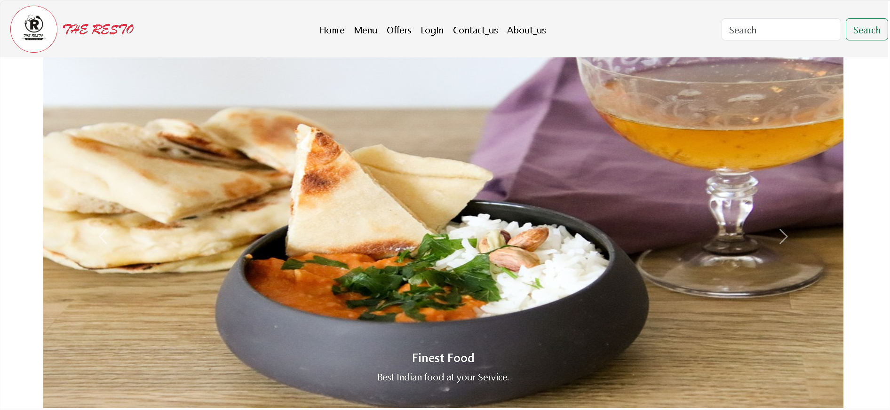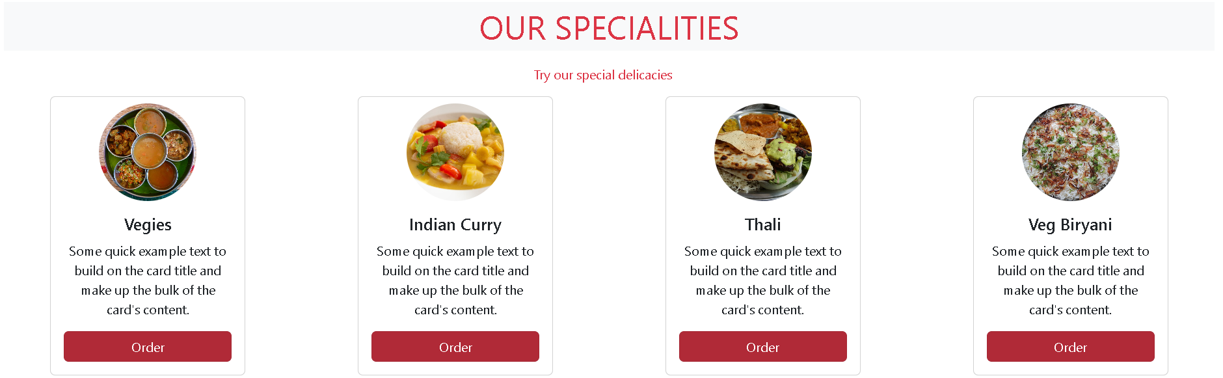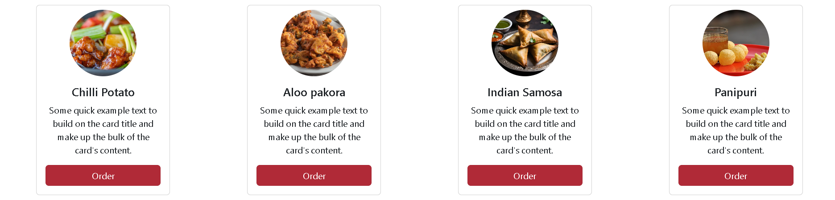

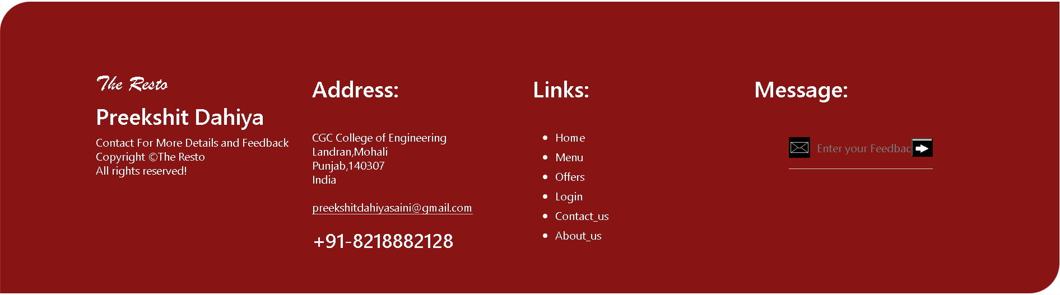

**Menu Page**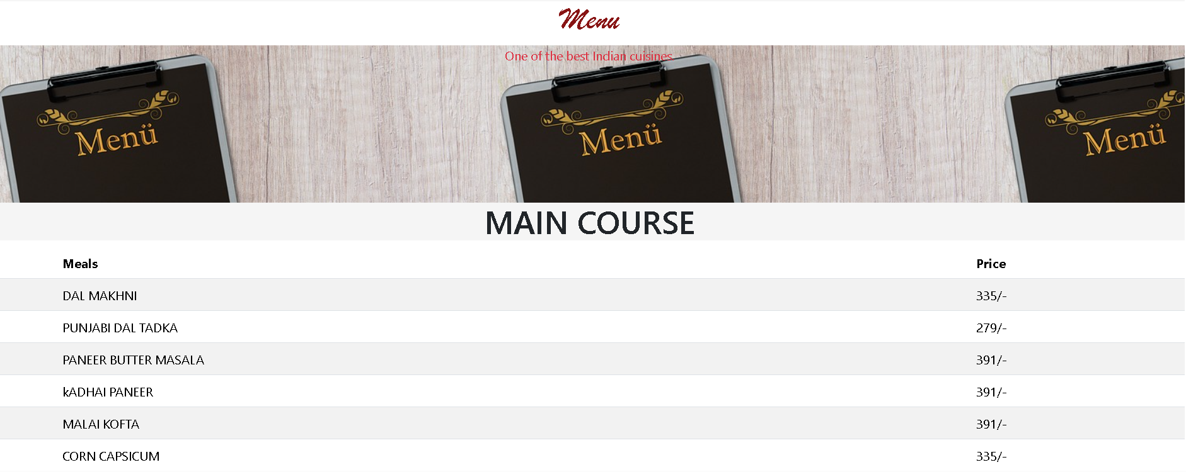 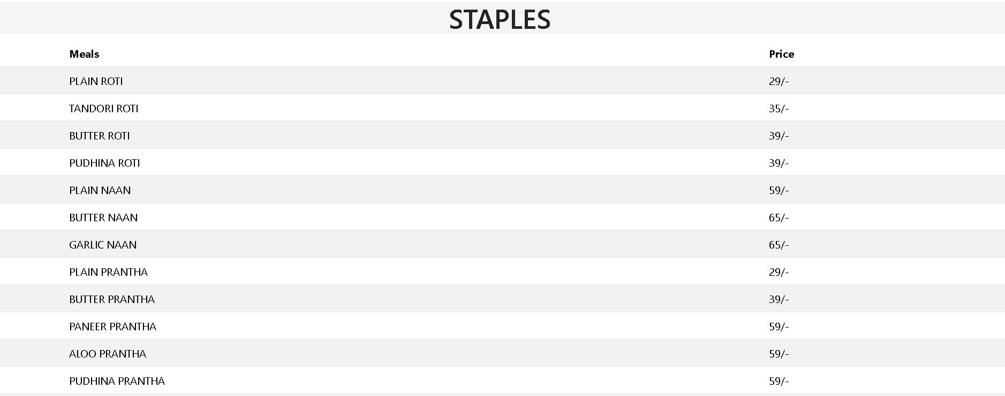 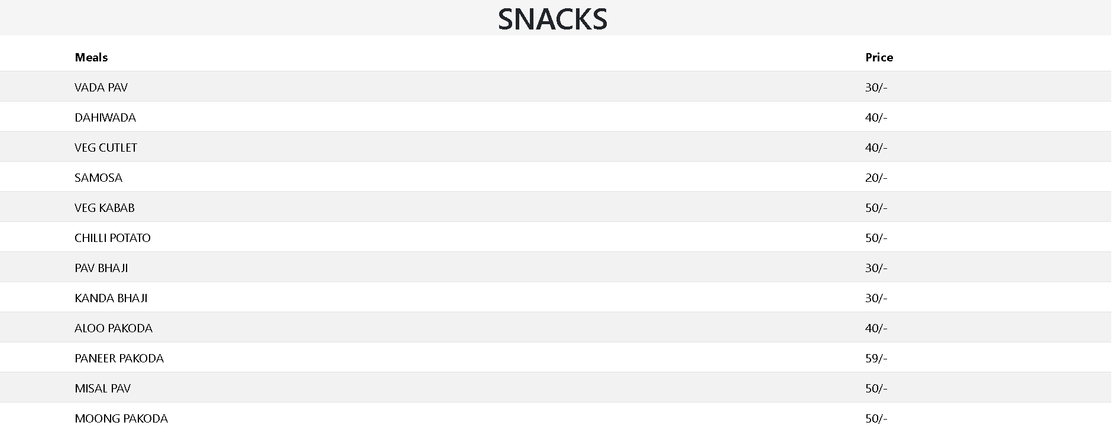

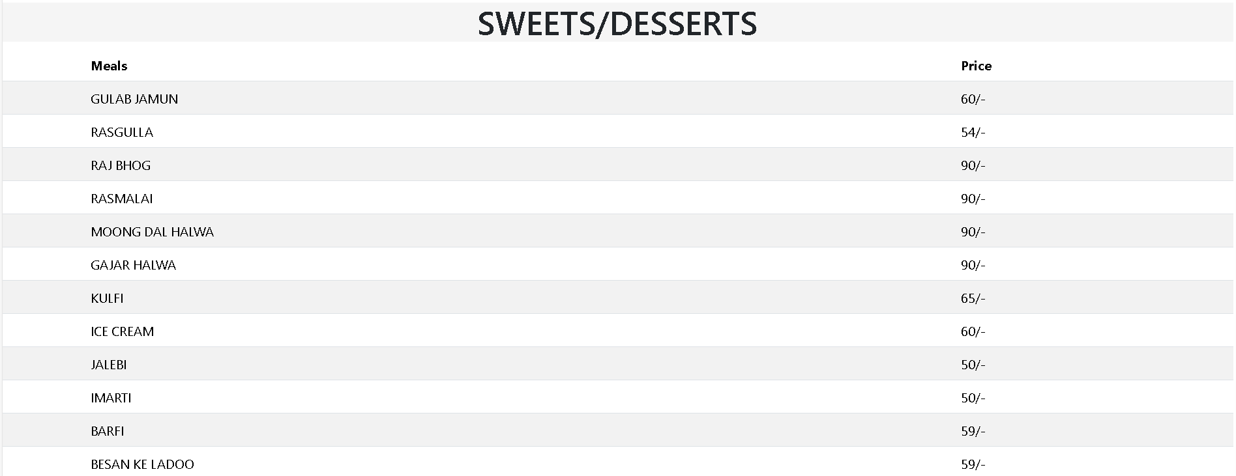

**Offers Page**



**Login Page**



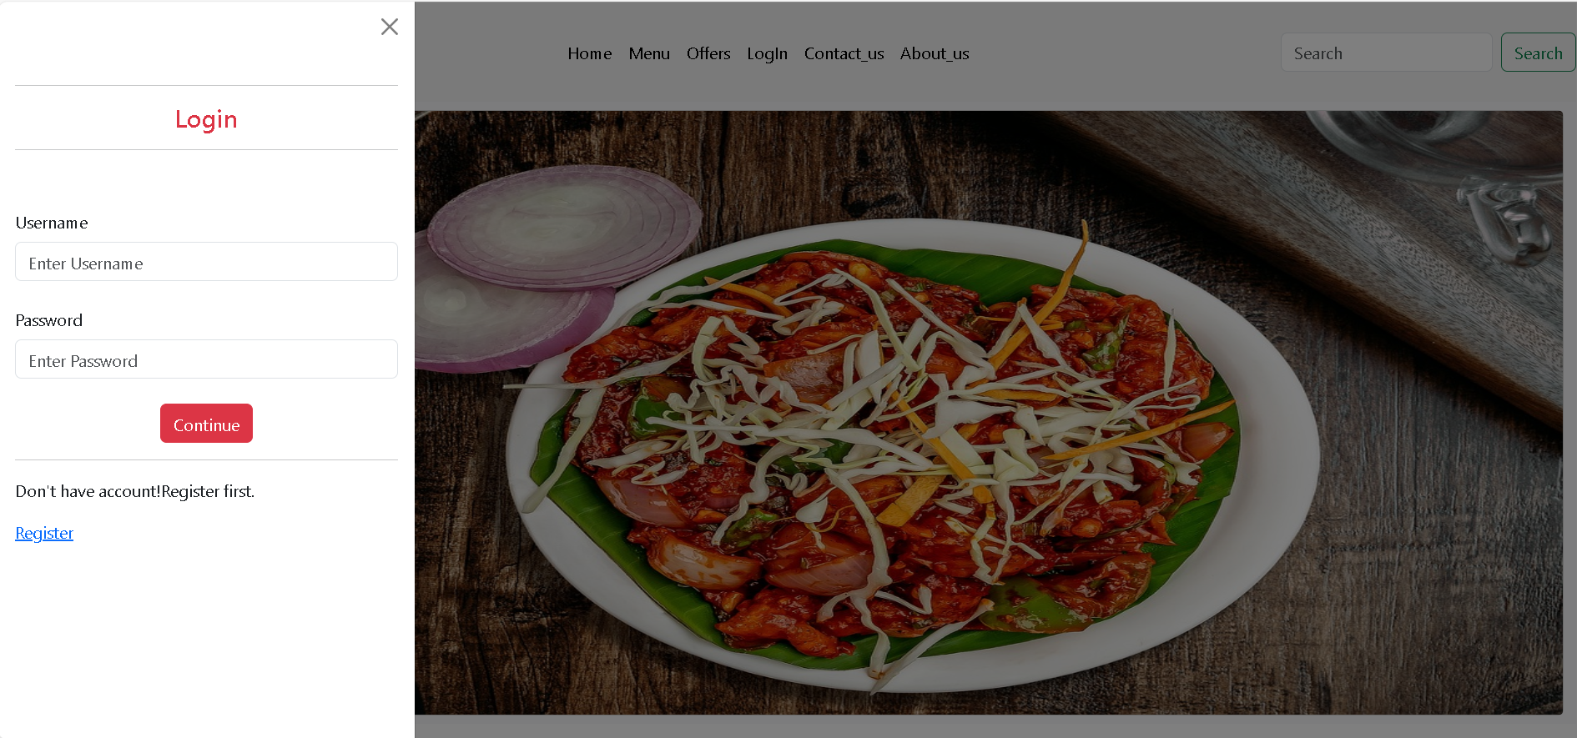

**Registration**



**Contact Page**

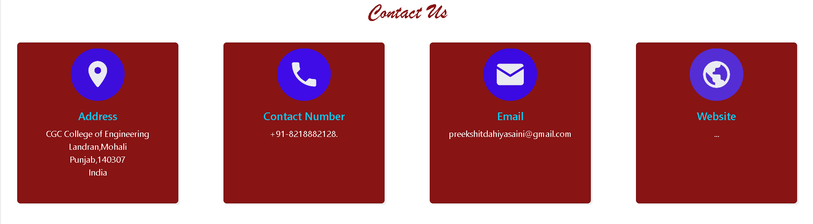 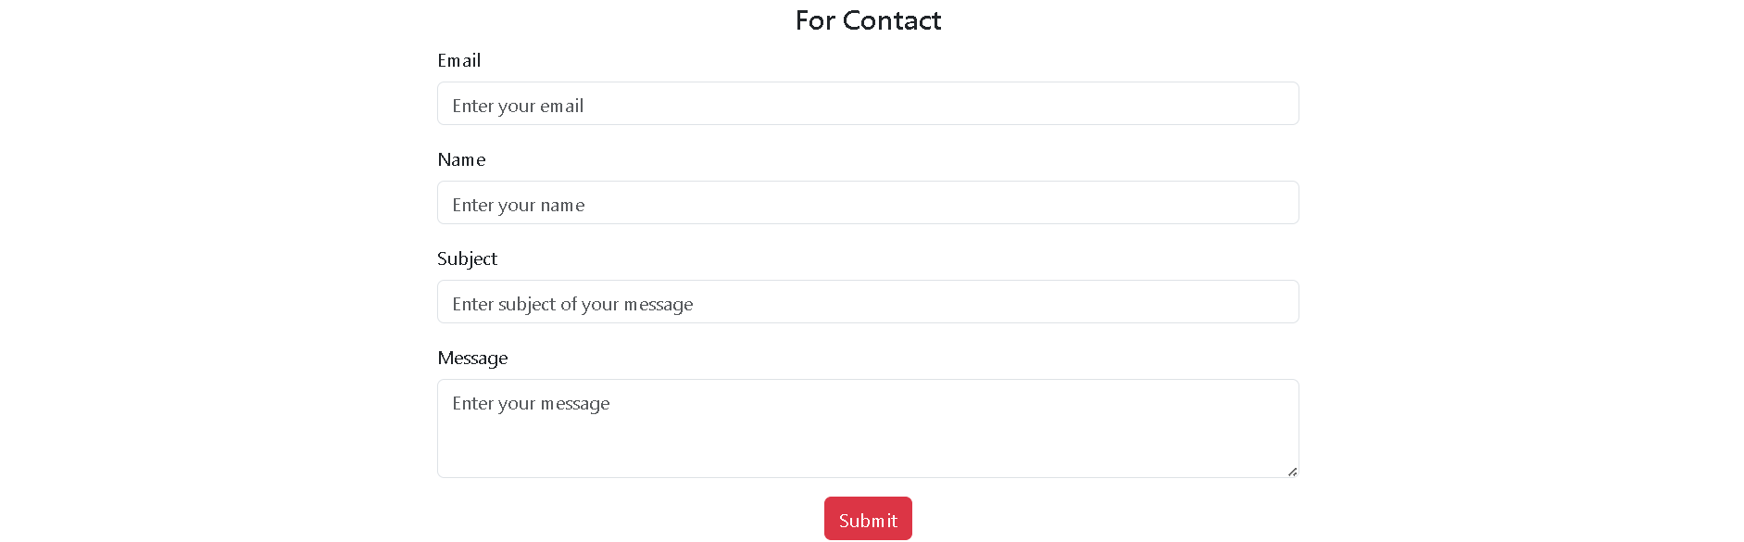

**About Us Page**

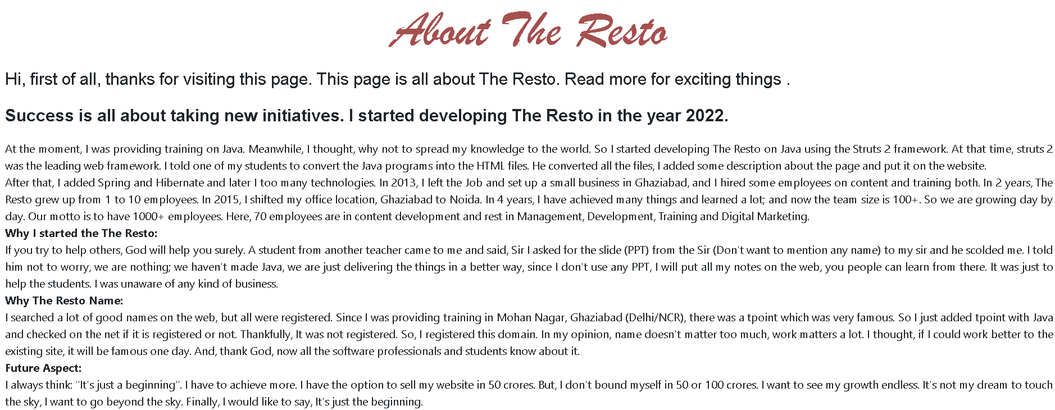

**5.2Test Cases and Results**

Following are the test cases to test the normal functioning of the website.

**Feedback message**

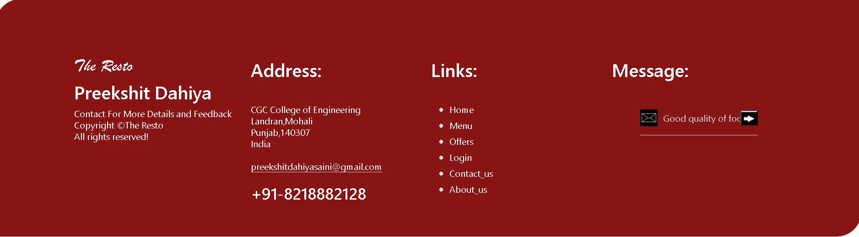

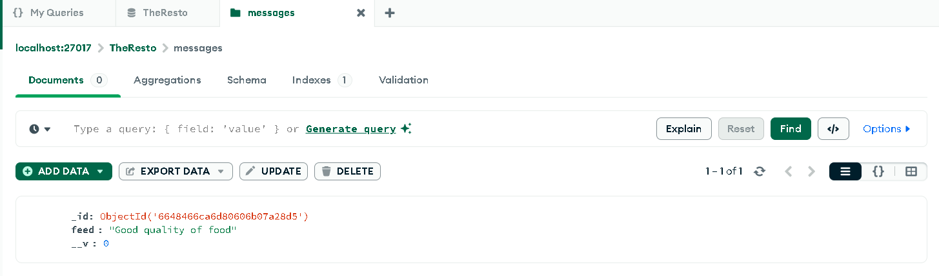

Feedback message is stored successfully.

**Contact Form**

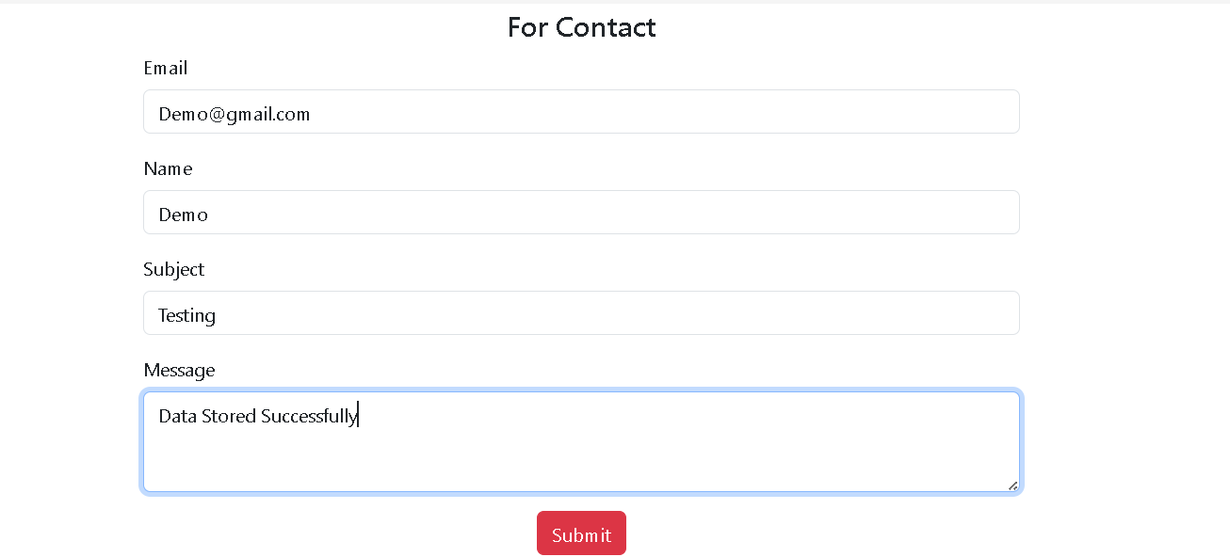

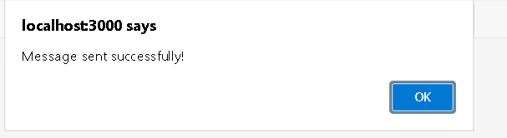

On submitting the form, alert is send to the user.

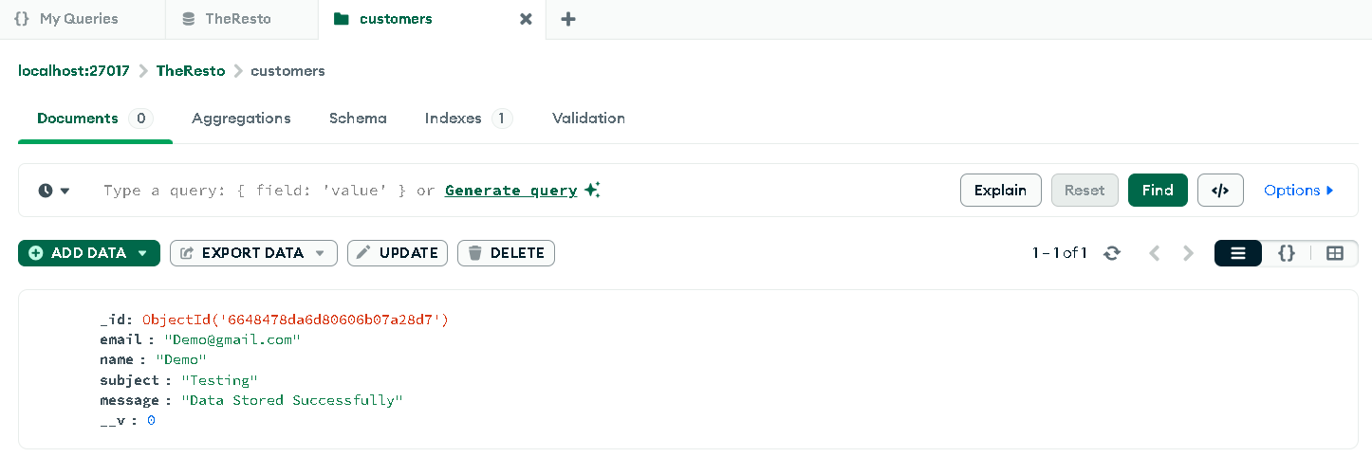

Data send by the form is stored in the database.

**Registration Form**

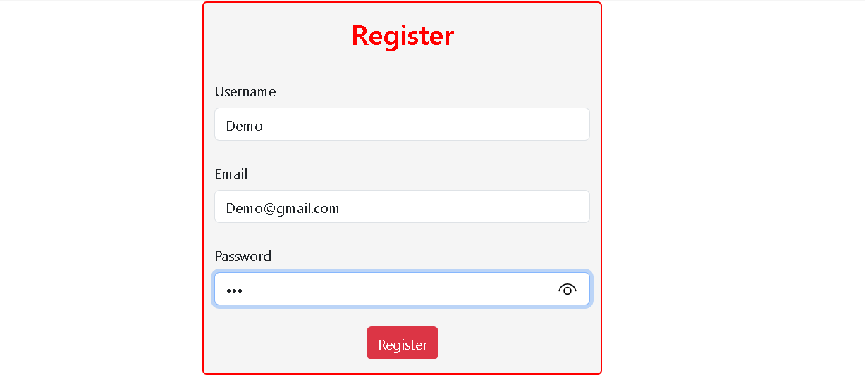

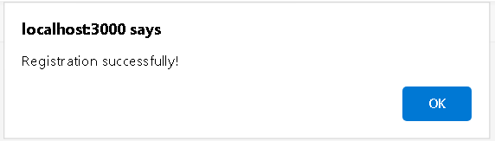

On submitting registration form, alert is send to the user

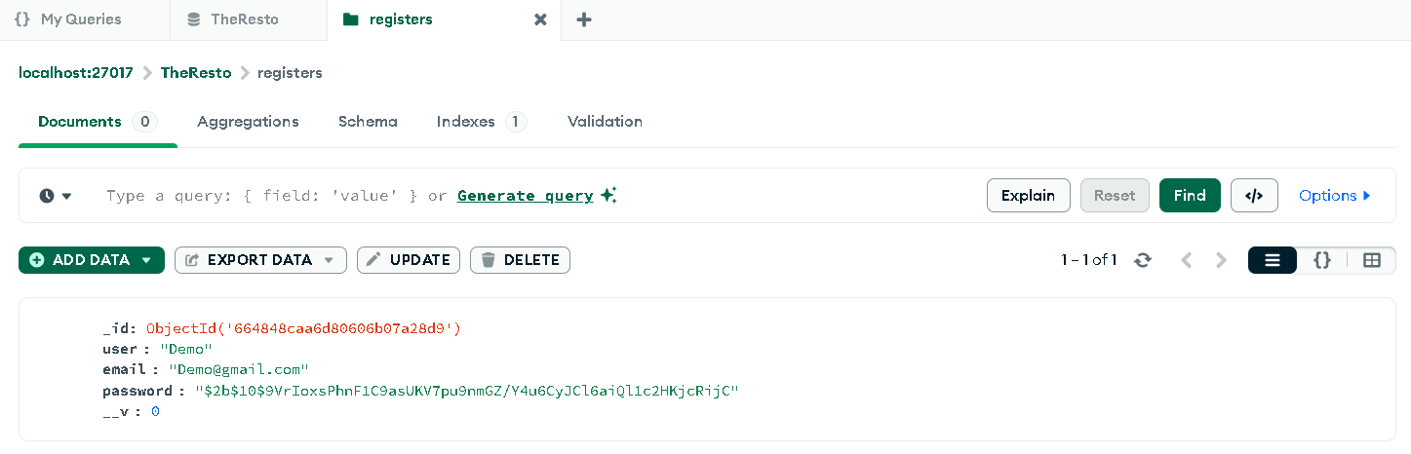

After registration of the user, user details are stored and password is encrypted using hashing for security reasons.

**Login form**

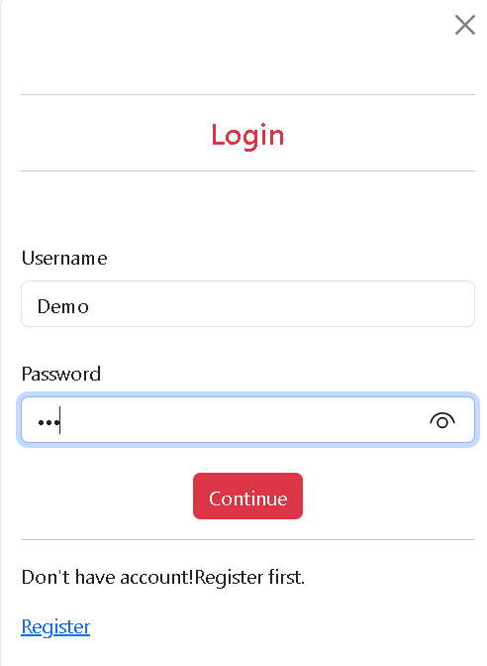

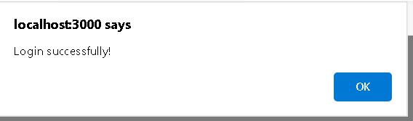

Alert is sent on successful login.



Username and Logout button are shown in the navbar after login.

**CHAPTER 6. CONCLUSION:**

It has been a great pleasure for me to work on this exciting and challenging project. This project proved good for me as it provided practical knowledge of not only programming in Full stack but also on web based application and on some extent Windows Application and Mongo DB Server, and also about all handling procedure related with project. It also provides knowledge about the latest technology used in developing web enabled application and client server technology that will be great demand in future. This will provide better opportunities and guidance in future in developing projects independently.

**Benefits**

• This project offers user to enter the data through simple and interactive forms. This is very helpful for the user to contact the owner through so much simplicity and give their feedback to the owner.

• The website is made responsive, understandable and lucrative using animations to attract special attention of the users.

• User data like login password are protected using encryption and hashing to make it more safe and secure.

• User is to send feedback about the meals as well as the services on the website.

• From every part of the project the user is provided with the navigation links through which he can navigate easily to the entire website without much confusion. This is bound to be simple and very friendly as per the user is concerned. That is, we can said that the project is user friendly which is one of the primary concerns of any good project.

• Data storage and retrieval will become faster and easier to maintain because data is stored in a collections and in a single database.

• Navigation also becomes faster due to the use of mern stack as it doesn’t need to reload the page again and again.

• Login and registration is done by using jsonwebtoken which a compact and secure way for authentication.

• Easier and faster data transfer through latest technology associated with the computer and communication.

• Through these features it will increase the efficiency, accuracy and transparency.

**Future work**

• Search engine optimization can be used for providing better search facility.

• Recommendations can be made to the customers by using artificial intelligence.

• User history can be stored and used for giving better suggestions.

• More payment options can be used for better usage of the website.

• Order tracking facility can also be added to provide user satisfaction.



Fig.11.Tracking the delivery

.

**REFERENCES:**

* <https://getbootstrap.com/>
* <https://nodejs.org/en>
* <https://pixabay.com/photos/>
* <https://www.istockphoto.com/>
* <https://icons8.com/icons>
* <https://www.w3schools.com/Css/>
* <https://michalsnik.github.io/aos/>
* [Online food delivery companies' performance and consumers expectations during Covid-19: An investigation using machine learning approach - PMC (nih.gov)](https://www.ncbi.nlm.nih.gov/pmc/articles/PMC9355939/)
* [MERN Stack Explained | MongoDB](https://www.mongodb.com/resources/languages/mern-stack)
* [Wikipedia](https://www.wikipedia.org/)